Zigbee

ZigBee is a specification for a suite of high level communication protocols using small, low-power digital radios based on the IEEE 802.15.4-2003 standard for Low-Rate Wireless Personal Area Networks (LR-WPANs), such as wireless light switches with lamps, electrical meters with in-home-displays, consumer electronics equipment via short-range radio. The technology defined by the ZigBee specification is intended to be simpler and less expensive than other WPANs, such as Bluetooth. ZigBee is targeted at radio-frequency (RF) applications that require a low data rate, long battery life, and secure networking.
ZigBee is a low-cost, low-power, wireless mesh networking standard. First, the low cost allows the technology to be widely deployed in wireless control and monitoring applications. Second, the low power-usage allows longer life with smaller batteries. Third, the mesh networking provides high reliability and more extensive range.
It is not capable of power line networking though other elements of the OpenHAN standards suite promoted by openAMI and UtilityAMI deal with communications co-extant with AC power outlets. In other words, ZigBee is intended not to support powerline networking but to interface with it at least for smart metering and smart appliance purposes. Utilities, e.g. Penn Energy, have declared the intent to require them to interoperate again via the openHAN standards.

Released Specifications
- ZigBee Home Automation
- ZigBee Smart Energy 1.0
- ZigBee Telecommunication Services
- ZigBee Health Care
- ZigBee Remote Control

Uses:
ZigBee protocols are intended for use in embedded applications requiring low data rates and low power consumption. ZigBee's current focus is to define a general-purpose, inexpensive, self-organizing mesh network that can be used for industrial control, embedded sensing, medical data collection, smoke and intruder warning, building automation, home automation, etc. The resulting network will use very small amounts of power — individual devices must have a battery life of at least two years to pass ZigBee certification.
Typical application areas include
- Home Entertainment and Control — Smart lighting, advanced temperature control, safety and security, movies and music
- Wireless Sensor Networks' — starting with individual sensors like Telosb/Tmote and Iris from Memsic.

Device types
There are three different types of ZigBee devices:
- ZigBee coordinator (ZC): The most capable device, the coordinator forms the root of the network tree and might bridge to other networks. There is exactly one ZigBee coordinator in each network since it is the device that started the network originally. It is able to store information about the network, including acting as the Trust Centre & repository for security keys.
- ZigBee Router (ZR): As well as running an application function, a router can act as an intermediate router, passing on data from other devices.
- ZigBee End Device (ZED): Contains just enough functionality to talk to the parent node (either the coordinator or a router); it cannot relay data from other devices. This relationship allows the node to be asleep a significant amount of the time thereby giving long battery life. A ZED requires the least amount of memory, and therefore can be less expensive to manufacture than a ZR or ZC.

History
- ZigBee-style networks began to be conceived around 1998, when many installers realized that both WiFi and Bluetooth were going to be unsuitable for many applications. In particular, many engineers saw a need for self-organizing ad-hoc digital radio networks.
- The IEEE 802.15.4-2003 standard was completed in May 2003 and has been superseded by the publication of IEEE 802.15.4-2006.
- In the summer of 2003, Philips Semiconductors, a major mesh network supporter, ceased the investment. Philips Lighting has, however, continued Philips' participation, and Philips remains a promoter member on the ZigBee Alliance Board of Directors.
- The ZigBee Alliance announced in October 2004 that the membership had more than doubled in the preceding year and had grown to more than 100 member companies, in 22 countries. By April 2005 membership had grown to more than 150 companies, and by December 2005 membership had passed 200 companies.
- The ZigBee specifications were ratified on 14 December 2004.
- The ZigBee Alliance announces public availability of Specification 1.0 on 13 June 2005, known as ZigBee 2004 Specification.
- The ZigBee Alliance announces the completion and immediate member availability of the enhanced version of the ZigBee Standard in September 2006, known as ZigBee 2006 Specification.
- During the last quarter of 2007, ZigBee PRO, the enhanced ZigBee specification was finalized.

Origin of ZigBee name
The name of the brand is originated with reference to the behaviour of honey bees after their return to the beehive

Features:
- Indoor/Urban: up to 100’ (30 m)
- Outdoor line-of-sight: up to 300’ (100 m)
- Transmit Power: 1 mW (0 dBm)
- Receiver Sensitivity: -92 dBm

Low Power

- TX Current: 45 mA (@3.3 V)
  - RX Current: 50 mA (@3.3 V)
  - Power-down Current: < 10 μA

Advanced Networking & Security

Retries and Acknowledgements
DSSS (Direct Sequence Spread Spectrum) for reliable long range delivery
16 direct sequence channels, each with over 65,000 unique network addresses available
128-bit Encryption (coming soon)
Self-routing/Self-healing mesh networking (coming soon)
Easy-to-Use

XBee & XBee-PRO Modules are interchangeable & pin-for-pin compatible Small Form Factor
No configuration necessary for out-of-box RF communications
Free Testing and Configuration Software included (X-CTU Software)
Software-selectable interface data rates:

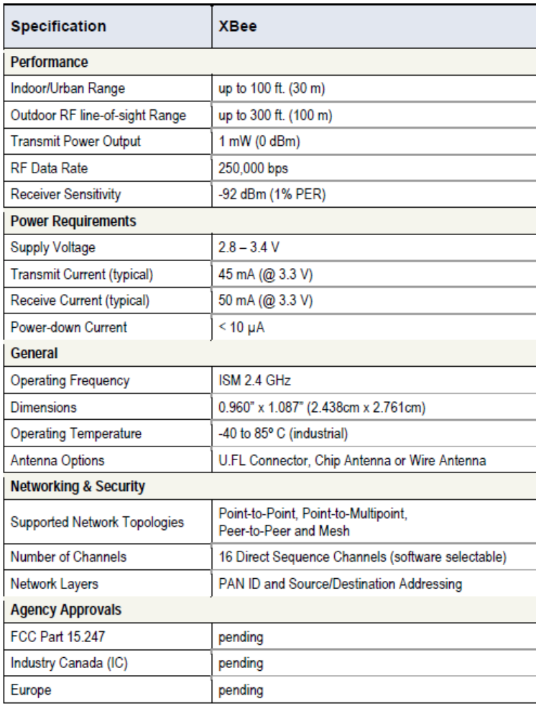

Pin Signals:

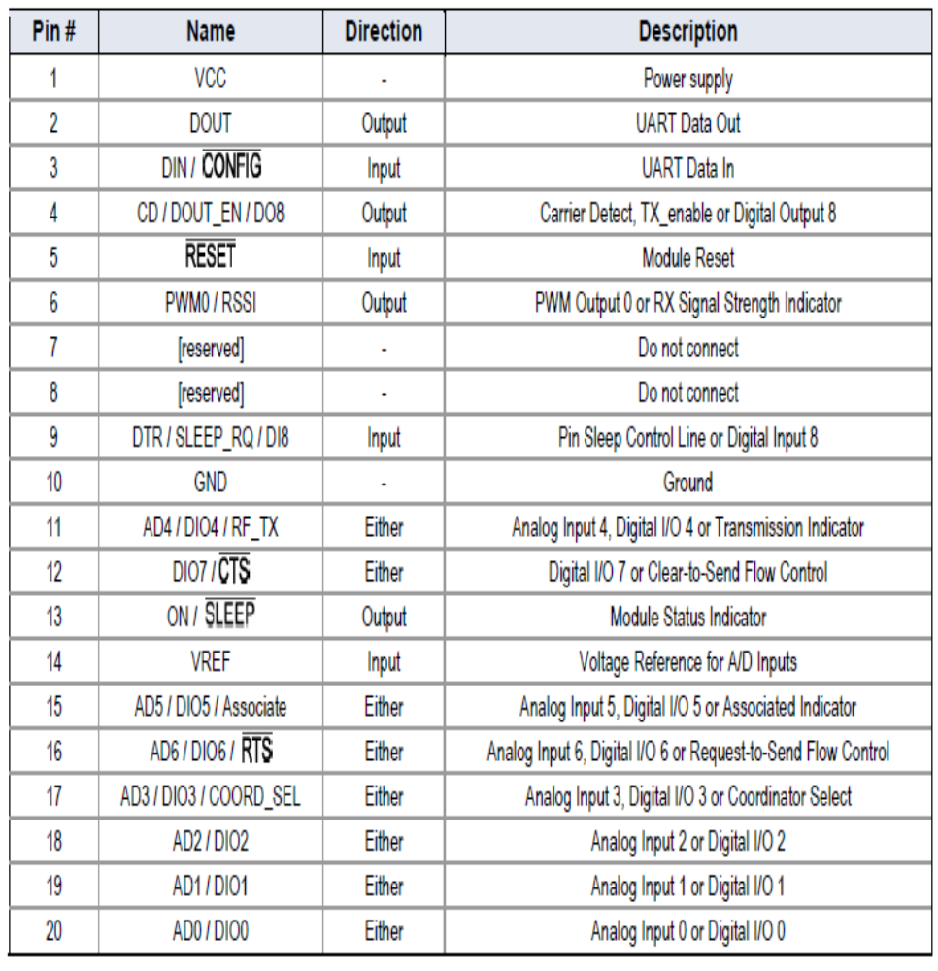

Electrical Characteristics:

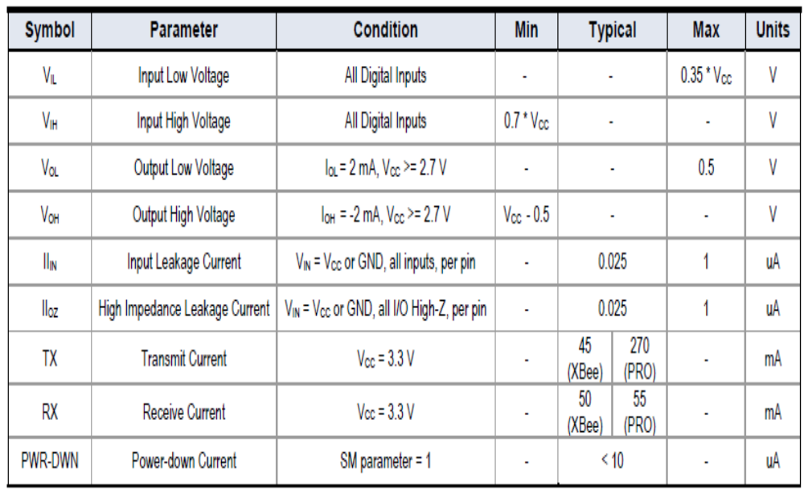

Serial Communications:
XBee and XBee-PRO Modules interface to a host device through a logic-level asynchronous serial port. Through its serial port, the module can communicate with any logic and voltage compatible UART; or through a level translator to any serial device (For example: RS-232/485/422 or USB interface board).

UART Data Flow:

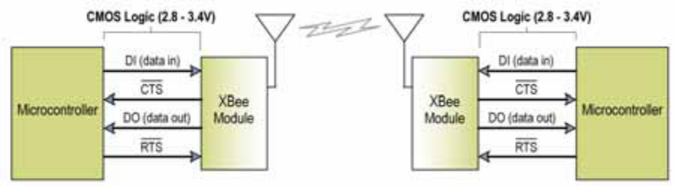

Serial Data:

Data enters the XBee Module UART through the DI pin (pin 3) as an asynchronous serial signal. The signal should idle high when no data is being transmitted. Each data byte consists of a start bit (low), 8 data bits (least significant bit first) and a stop bit (high). The following figure illustrates the serial bit pattern of data passing through the module.
UART data packet 0x1F (decimal number “31”) as transmitted through the XBee Module
Example Data Format is 8‐N‐1 (bits – parity ‐ # of stop bits)

